SAP PowerDesigner
Object-Oriented Model Report

Model: Use Case Diagram_2
Report: Full Object Report



Author: Lenovo
Version:
Date: 5/10/2026
Summary:

Table of Contents

The 'Table of Contents' field needs to be updated!

Specifications
Insert specifications here...

Model information

Card of model Use Case Diagram_2
Name | Use Case Diagram_2
Code | Use_Case_Diagram_2
Comment

OOM Diagrams

Model level diagrams

Diagram Use Case Diagram_2
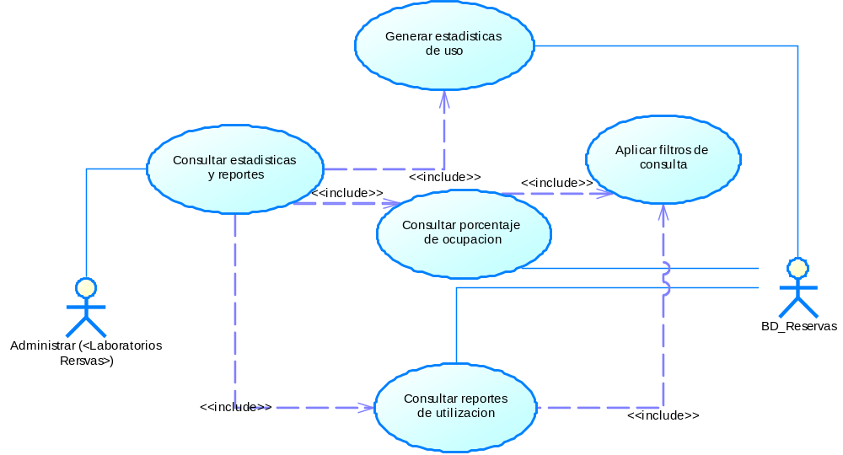

Common objects

Actors

Model level actors

List of actors
Name | Code | Parent
Administrar (<Laboratorios Rersvas>) | Administrar___Laboratorios_Rersvas__ | Object-Oriented Model 'Use Case Diagram_2'
BD_Reservas | BD_Reservas | Object-Oriented Model 'Use Case Diagram_2'

Dependencies

Model level dependencies

List of dependencies
Name | Code | Influent Object | Dependent Object
Dependency_1 | Dependency_1 | Generar estadisticas de uso | Consultar estadisticas y reportes
Dependency_2 | Dependency_2 | Consultar porcentaje de ocupacion | Consultar estadisticas y reportes
Dependency_3 | Dependency_3 | Consultar reportes de utilizacion | Consultar estadisticas y reportes
Dependency_4 | Dependency_4 | Aplicar filtros de consulta | Consultar porcentaje de ocupacion
Dependency_5 | Dependency_5 | Aplicar filtros de consulta | Consultar reportes de utilizacion

Dependency Dependency_1

Card of dependency Dependency_1
Name | Dependency_1
Code | Dependency_1
Influent Object | Generar estadisticas de uso
Dependent Object | Consultar estadisticas y reportes

List of diagrams containing the dependency Dependency_1
Name | Code
Use Case Diagram_2 | Use_Case_Diagram_2

List of extended attributes of the dependency Dependency_1
Name | Data Type | Value | Target Name
CommunicationDataType | CommunicationDataTypes |  | Technical Architecture Modeling (TAM)
CommunicationProtocol | CommunicationProtocols |  | Technical Architecture Modeling (TAM)

Dependency Dependency_2

Card of dependency Dependency_2
Name | Dependency_2
Code | Dependency_2
Influent Object | Consultar porcentaje de ocupacion
Dependent Object | Consultar estadisticas y reportes

List of diagrams containing the dependency Dependency_2
Name | Code
Use Case Diagram_2 | Use_Case_Diagram_2

List of extended attributes of the dependency Dependency_2
Name | Data Type | Value | Target Name
CommunicationDataType | CommunicationDataTypes |  | Technical Architecture Modeling (TAM)
CommunicationProtocol | CommunicationProtocols |  | Technical Architecture Modeling (TAM)

Dependency Dependency_3

Card of dependency Dependency_3
Name | Dependency_3
Code | Dependency_3
Influent Object | Consultar reportes de utilizacion
Dependent Object | Consultar estadisticas y reportes

List of diagrams containing the dependency Dependency_3
Name | Code
Use Case Diagram_2 | Use_Case_Diagram_2

List of extended attributes of the dependency Dependency_3
Name | Data Type | Value | Target Name
CommunicationDataType | CommunicationDataTypes |  | Technical Architecture Modeling (TAM)
CommunicationProtocol | CommunicationProtocols |  | Technical Architecture Modeling (TAM)

Dependency Dependency_4

Card of dependency Dependency_4
Name | Dependency_4
Code | Dependency_4
Influent Object | Aplicar filtros de consulta
Dependent Object | Consultar porcentaje de ocupacion

List of diagrams containing the dependency Dependency_4
Name | Code
Use Case Diagram_2 | Use_Case_Diagram_2

List of extended attributes of the dependency Dependency_4
Name | Data Type | Value | Target Name
CommunicationDataType | CommunicationDataTypes |  | Technical Architecture Modeling (TAM)
CommunicationProtocol | CommunicationProtocols |  | Technical Architecture Modeling (TAM)

Dependency Dependency_5

Card of dependency Dependency_5
Name | Dependency_5
Code | Dependency_5
Influent Object | Aplicar filtros de consulta
Dependent Object | Consultar reportes de utilizacion

List of diagrams containing the dependency Dependency_5
Name | Code
Use Case Diagram_2 | Use_Case_Diagram_2

List of extended attributes of the dependency Dependency_5
Name | Data Type | Value | Target Name
CommunicationDataType | CommunicationDataTypes |  | Technical Architecture Modeling (TAM)
CommunicationProtocol | CommunicationProtocols |  | Technical Architecture Modeling (TAM)

Use case objects

Model level use cases

Use case association Association_1

Card of use case association Association_1
Name | Association_1
Code | Association_1
Parent | Object-Oriented Model 'Use Case Diagram_2'
Destination | Consultar estadisticas y reportes
Source | Administrar (<Laboratorios Rersvas>)

Use case association Association_2

Card of use case association Association_2
Name | Association_2
Code | Association_2
Parent | Object-Oriented Model 'Use Case Diagram_2'
Destination | Consultar porcentaje de ocupacion
Source | BD_Reservas

Use case association Association_3

Card of use case association Association_3
Name | Association_3
Code | Association_3
Parent | Object-Oriented Model 'Use Case Diagram_2'
Destination | Consultar reportes de utilizacion
Source | BD_Reservas

Use case association Association_4

Card of use case association Association_4
Name | Association_4
Code | Association_4
Parent | Object-Oriented Model 'Use Case Diagram_2'
Destination | Generar estadisticas de uso
Source | BD_Reservas

List of use cases
Name | Code | Parent
Aplicar filtros de consulta | Aplicar_filtros_de_consulta | Object-Oriented Model 'Use Case Diagram_2'
Consultar estadisticas y reportes | Consultar_estadisticas_y_reportes | Object-Oriented Model 'Use Case Diagram_2'
Consultar porcentaje de ocupacion | Consultar_porcentaje_de_ocupacion | Object-Oriented Model 'Use Case Diagram_2'
Consultar reportes de utilizacion | Consultar_reportes_de_utilizacion | Object-Oriented Model 'Use Case Diagram_2'
Generar estadisticas de uso | Generar_estadisticas_de_uso | Object-Oriented Model 'Use Case Diagram_2'

Use case Aplicar filtros de consulta

Card of use case Aplicar filtros de consulta
Name | Aplicar filtros de consulta
Code | Aplicar_filtros_de_consulta
Parent | Object-Oriented Model 'Use Case Diagram_2'

List of all dependencies of the use case Aplicar filtros de consulta
Name | Code | Class Name
Dependency_4 | Dependency_4 | Dependency
Dependency_5 | Dependency_5 | Dependency

Use case Consultar estadisticas y reportes

Card of use case Consultar estadisticas y reportes
Name | Consultar estadisticas y reportes
Code | Consultar_estadisticas_y_reportes
Parent | Object-Oriented Model 'Use Case Diagram_2'

List of all dependencies of the use case Consultar estadisticas y reportes
Name | Code | Class Name
Association_1 | Association_1 | Use Case Association
Dependency_1 | Dependency_1 | Dependency
Dependency_2 | Dependency_2 | Dependency
Dependency_3 | Dependency_3 | Dependency

Use case Consultar porcentaje de ocupacion

Card of use case Consultar porcentaje de ocupacion
Name | Consultar porcentaje de ocupacion
Code | Consultar_porcentaje_de_ocupacion
Parent | Object-Oriented Model 'Use Case Diagram_2'

List of all dependencies of the use case Consultar porcentaje de ocupacion
Name | Code | Class Name
Association_2 | Association_2 | Use Case Association
Dependency_2 | Dependency_2 | Dependency
Dependency_4 | Dependency_4 | Dependency

Use case Consultar reportes de utilizacion

Card of use case Consultar reportes de utilizacion
Name | Consultar reportes de utilizacion
Code | Consultar_reportes_de_utilizacion
Parent | Object-Oriented Model 'Use Case Diagram_2'

List of all dependencies of the use case Consultar reportes de utilizacion
Name | Code | Class Name
Association_3 | Association_3 | Use Case Association
Dependency_3 | Dependency_3 | Dependency
Dependency_5 | Dependency_5 | Dependency

Use case Generar estadisticas de uso

Card of use case Generar estadisticas de uso
Name | Generar estadisticas de uso
Code | Generar_estadisticas_de_uso
Parent | Object-Oriented Model 'Use Case Diagram_2'

List of all dependencies of the use case Generar estadisticas de uso
Name | Code | Class Name
Association_4 | Association_4 | Use Case Association
Dependency_1 | Dependency_1 | Dependency

List of use case associations
Name | Code | Parent | Destination | Source
Association_1 | Association_1 | Object-Oriented Model 'Use Case Diagram_2' | Consultar estadisticas y reportes | Administrar (<Laboratorios Rersvas>)
Association_2 | Association_2 | Object-Oriented Model 'Use Case Diagram_2' | Consultar porcentaje de ocupacion | BD_Reservas
Association_3 | Association_3 | Object-Oriented Model 'Use Case Diagram_2' | Consultar reportes de utilizacion | BD_Reservas
Association_4 | Association_4 | Object-Oriented Model 'Use Case Diagram_2' | Generar estadisticas de uso | BD_Reservas

